63BITS Solution Structure
This document is designed to describe how 63BITS applications are structured, what is the folder and file structure, what rules, patterns and guidelines we use and follow for achieving the best results.

Terms Used
Domain – https://en.wikipedia.org/wiki/Domain_(software_engineering)
Monolithic – https://www.educative.io/answers/what-is-a-monolithic-application
Module – https://www.educative.io/answers/what-are-code-modules
Deferred Execution – https://weblogs.asp.net/dixin/understanding-linq-to-sql-6-working-with-deferred-execution

Dev Stack
Application structure – Monolithic
IDE – Visual Studio
Application Framework – .NET CORE (latest version)
Object Relational Mapping Database Tools – Entity Framework Core
Application Development Framework – ASP.NET Core MVC
Application Development Third Party Libraries – DevExpress/DevExtreme
Presentation Development Framework – MVC Razor Pages
Presentation Development Third Party Libraries – Bootstrap, jQuery

Solution Structure
The application uses monolithic architecture and consists of two projects:
- SixtyThreeBits.Core – Contains repositories, API services, business logic, utilities, abstractions and shared libraries.
- SixtyThreeBits.Web – An ASP.NET Core web application that includes models, view-models, controllers, views, web specific libraries and static assets (Images, JavaScript, CSS).

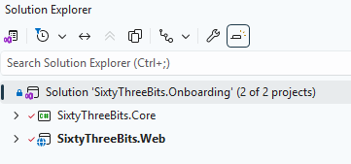

SixtyThreeBits.Core
This class library represents the core domain of the application. It handles database interactions via repositories, external web service api calls, business logic, libraries, entities, value objects, utilities and abstractions.
Below is an overview of the SixtyThreeBits.Core folder structure.
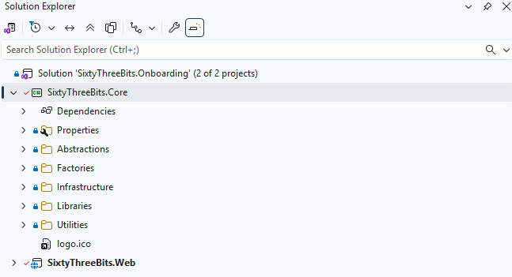

Abstractions
Contains domain-level interfaces shared across all application layers. Any interface required by multiple layers should be defined here.

Factories
Includes factory classes responsible for creating instances of Repositories, DbContext, Services, Libraries, and other objects essential to the application.

Infrastructure
Houses data management components. This includes database access and external web service api communication.

Libraries
Contains reusable libraries, not directly related to database or api calls, perform specific or specialized functions.

Utilities
Includes general-purpose utilities such as application settings, formatters, constants, enums, and helper functions used throughout the domain.

SixtyThreeBits.Web
SixtyThreeBits.Web is an ASP.NET Core MVC web application that serves as the presentation and application layer of the system. It references the SixtyThreeBits.Core project to access repositories, services, libraries, domain abstractions, and utilities.
The project is organized into the following directories:
- wwwroot – Static assets and client resources
- Controllers – MVC controller classes
- Domain – Web-specific libraries, shared view-models and utilities
- Filters – Action filter attributes
- Models – Model and ViewModel classes
- Views – View templates and layouts.

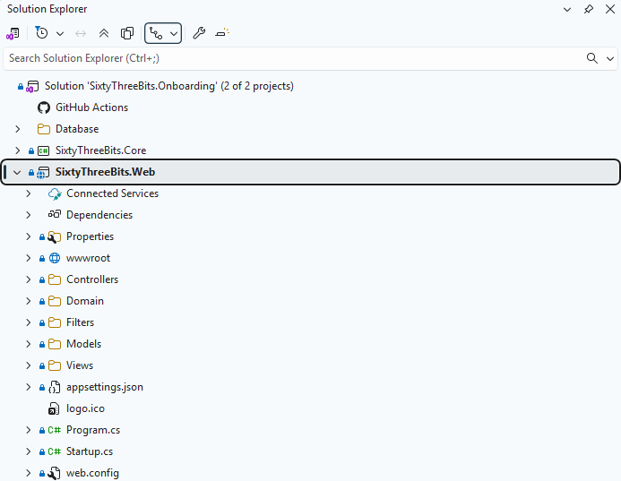

wwwroot
Directory containing all static assets served to the client, including website images, stylesheets, JavaScript files, and third-party libraries used as plugins.
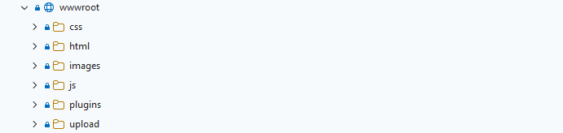

Controllers
Contains all MVC controller classes, organized into three subfolders: Admin and Website representing distinct application areas, and Base containing base controller classes shared across all areas.
- Admin – Controllers for administrative functionality
- Base – Base controller class inherited by all other controllers
- Website – Controllers for public-facing website pages

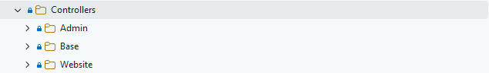

Domain
Contains classes and libraries providing web-application-specific functionality, organized into three subfolders:
- Libraries – Reusable library classes specific to the Web project.
- Utilities – Helper and utility classes specific to the Web project.
- ViewModels – ViewModel classes exclusively for partial views and layouts (not for regular views).
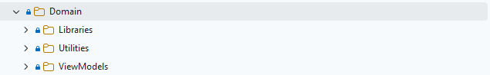

Filters
Contains MVC Action Filter attribute classes, organized into two subfolders representing distinct application areas:
- Admin – Filter attributes for administrative controllers
- Website – Filter attributes for public-facing website controllers
Action filters are critical components that influence application behavior and are essential to system functionality. For detailed information on implementing custom filter attributes, refer to the following resources:
- https://devblogs.microsoft.com/dotnet/attribute-routing-in-asp-net-mvc-5/
- https://www.tutorialspoint.com/asp.net_mvc/asp.net_mvc_filters.htm

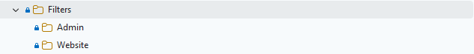

Models
Contains all MVC Model classes, organized into three subfolders: Admin and Website representing distinct application areas, and Base containing base model classes shared across all areas.
- Admin – Model classes for administrative functionality
- Base – Base Model class inherited by all other models
- Website – Model classes for public-facing website pages
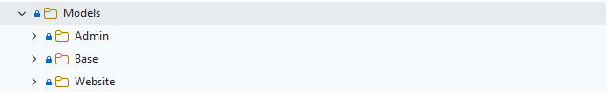

Views
Contains all view templates and layouts, organized into three subfolders: Admin and Website representing distinct application areas, and Shared containing partial views and common components used across both areas.
- Admin – View templates and layouts for administrative pages.
- Website – View templates and layouts for public-facing website pages.
- Shared – Partial views and common components used across Admin and Website areas.
